Newbiggin Town Council & Sports Development
Newbiggin Leisure Programme 2025/
October 2025 – March 2026
(Quarter 3 & Quarter 4)
School Holiday Figures
October 2025 February 2026
Number of Sports camps = 3 | Number of Sports camps = 4
Number of hours of activities = 6 | Number of hours of activities = 6.45
Number of outreach sessions = 2 | Number of outreach sessions = 2
Number of drop-in sessions = 2 | Number of drop-in sessions = 2
Number of attendances = 62 | Number of attendances = 139
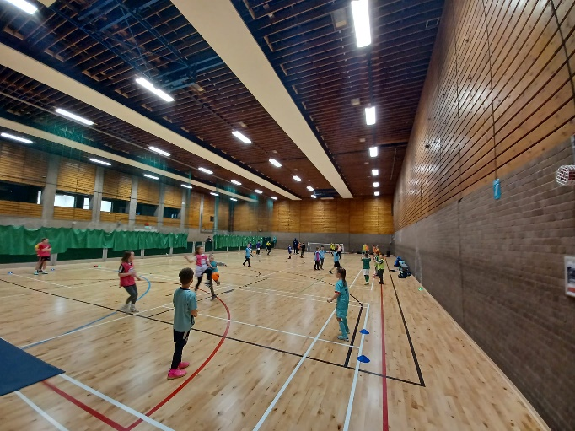
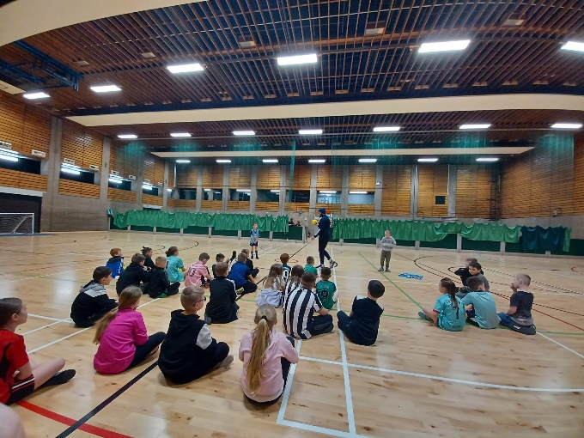

Holiday Camps
Half Term Camps (October, February) Ages 3-13
In 2025, our school holiday programme in Newbiggin continued its positive trajectory, filled with responsive changes and enthusiastic participation. This year, we introduced an 'Active Soft Play' session during February Half Term, addressing families' desires for inclusive activities. Partnering with Newbiggin Hive for the February programme also proved successful, with over 100 attendees across the busy week. Our camps remained a hub of community engagement, with increased drop-in sessions and outreach ensuring more children could partake in the fun. We also reinstated balance bike sessions, fostering connections with even the youngest members of our community. The continued smiles and positive feedback attest to the continued impact and success of our programme with Newbiggin Town Council

Community Project - Term Time Schools & Community Programme
Friday Football Club
Our Friday Football session continues to be a valued part of our programme, offering children a fun and engaging after school activity. We have a strong and committed core of participants who attend regularly, giving them the opportunity to develop skills, build friendships and enjoy being active together. A key strength of this session is that it gives young people the chance to play football in an informal setting, without the pressure of joining or committing to a club, which many find appealing. By maintaining a positive, safe and welcoming environment, we ensure a rewarding experience for both the children and our coaches. Looking ahead, our aim is to sustain participation, gently broaden our reach and refresh the format by moving the session to Friday evenings rather than Thursdays. Through this, we hope to continue making a lasting positive impact, supporting children’s development both in sport and in their everyday lives. We have seen a great success in number grow as we deliver session in school to help promote the session.
1/10/2025 - 31/03/2026 (Not including holidays)
Attendances – 152
Outreach Programme
While maintaining our commitment to fostering safe and welcoming environments within our sports camps and activity clubs, our outreach programme has continued to prove valuable in engaging with those young people who might not have the confidence to set foot through the hub’s doors. Recognising the challenges some children and parents face in accessing our Newbiggin sports hub, we've adapted by bringing our activities directly to them. Our outreach now spans across numerous areas of Newbiggin, reaching diverse locations such as beaches, parks, fields and playzone effectively showcasing the fun and games offered by our clubs. Through these efforts, we've not only engaged children but also connected with the wider community, including parents and guardians. Despite the informal nature of these sessions, we've consistently seen really good engagement, demonstrating the positive impact and reach of our outreach endeavours. As we continue to expand and innovate, our goal remains clear: to break down barriers to participation and ensure that every child in Newbiggin has access to the enriching experiences we offer.
Walking Football
Building upon the success of our highly popular walking football program, 2024 has seen continued demand and enthusiasm at Newbiggin sports hub. Due to its popularity, we often find ourselves accommodating three teams on Monday mornings to meet the high number of participants. This setup ensures ample playing time for everyone while also fostering important social connections, highlighting the holistic benefits of our walking football initiative.
1/10/2025 - 31/03/2026
Attendances - 513
Active Soft Play

Following the success of our soft play sessions during the school holidays, and in response to parents requesting more opportunities, we have continued to do this session every Friday. This session has seen huge growth in the new year as we merge with the Family hub to deliver a combined sessions for the little ones. The sessions has and continues to provide a safe, clean and enjoyable space for babies and young children to play, with activities such as a bouncy castle, foam blocks, toys and more. Importantly, these sessions are free of charge and will also offer parents a welcoming environment to connect and socialise with one another as well as partners that come along such as learning hive.
1/10/2025 - 31/03/2026
Attendances - 432

