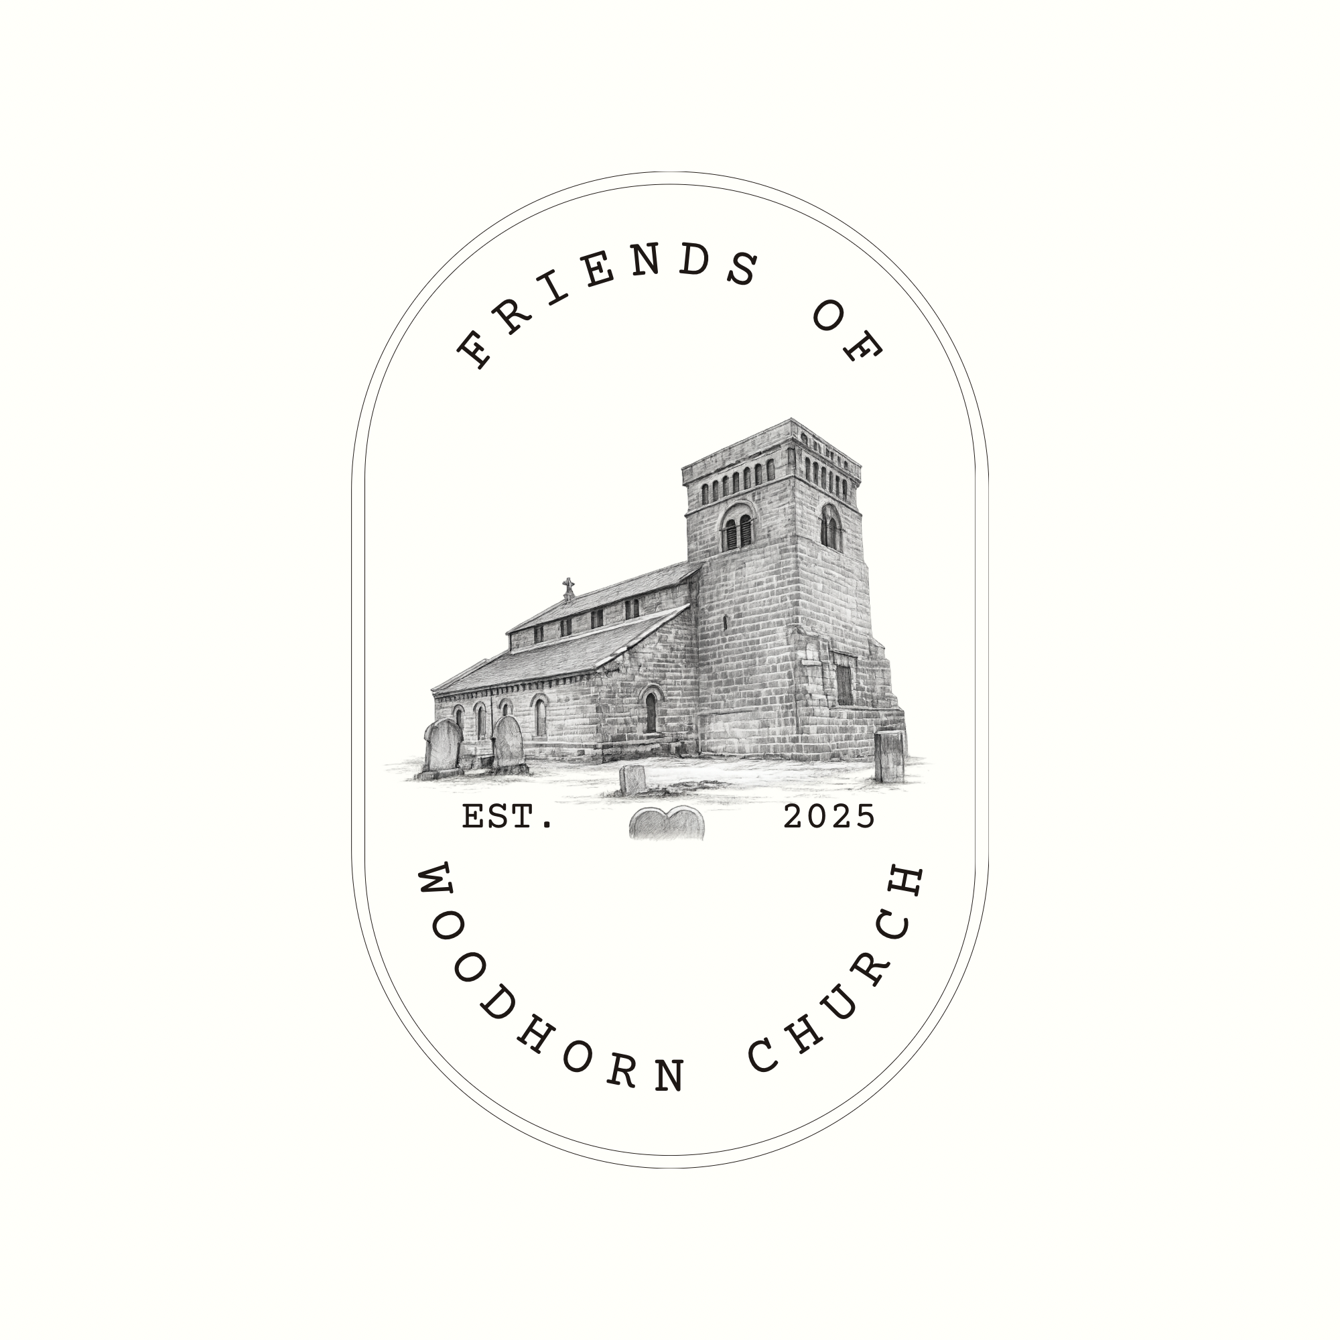

Summary
March 2026

1. Purpose
This paper provides a concise, policy-aligned summary of the Friends of Woodhorn Church (FOWC), and our emerging proposals for a Community Asset Transfer of St Mary’s Church, Woodhorn.

2. The organisation
Friends of Woodhorn Church (FOWC) is a locally-led voluntary group re-established in 2025 to continue community stewardship of St Mary’s Church following the retirement of long-standing volunteers.
FOWC is in the process of incorporating as a Charitable Incorporated Organisation (CIO), providing:
- a recognised legal entity,
- limited liability for trustees,
- appropriate governance for asset ownership or long-term lease,
- compliance with Charity Commission and public-sector partner expectations.
Proposed trustees bring experience in leadership, finance, community development, and heritage, supported by honorary advisors with relevant sector expertise.

3. The asset and strategic context
St Mary’s Church, Woodhorn is a Grade I listed heritage asset of county-wide significance, currently vacant and vulnerable to deterioration, misuse, and escalating maintenance costs.
The site sits within a wider regeneration and growth corridor encompassing Ashington, Newbiggin-by-the-Sea, Lynemouth and North Seaton, and aligns with:
- heritage-led regeneration objectives,
- tourism and cultural development priorities,
- community ownership and civic participation agendas,
- place-based approaches to wellbeing and identity.
A community-led future for the building offers the potential to reduce the owners long term holding risk and maintenance liability, while securing public benefit.

4. Vision and outcomes
‘FOWC’s long-term objective is to secure, preserve, and place St Mary’s Church into sustainable community use, delivering measurable public value.’
Intended outcomes include:
- safeguarding a nationally significant heritage asset;
- enabling regular public access and inclusive community use;
- supporting education, heritage interpretation, arts and cultural activity;
- contributing to local distinctiveness, tourism, and civic pride;
- operating the asset for public benefit on a not-for-profit basis.
Delivery would be phased, proportionate to volunteer capacity, funding secured, and risk managed.

5. Delivery approach and sustainability
FOWC recognises that full transfer would require:
- a detailed condition survey and conservation advice,
- a costed and tested business plan,
- clarity on repair and maintenance liabilities,
- appropriate insurance, health and safety, and safeguarding arrangements.
Subject to development funding, sustainability would be achieved through:
- grant funding for capital works,
- donations and membership income,
- modest earned income from events, exhibitions, and appropriate ceremonies,
- ongoing volunteer involvement and partnerships.

6. Immediate actions by FOWC
- Formal incorporation and registration as a charity
- Establishment of core governance and financial controls
- Monthly project meetings and volunteer coordination
- Engagement with key partners
- Preparation for development-stage funding applications

