Minutes of the Ordinary Meeting of Newbiggin by the Sea Town Council held at 6:30 pm on Wednesday, 18th February 2026 at St Bartholomew’s Church Centre.

PRESENT: Councillors: J Casey (Vice Chair), M Martin, T Roll, A Sutherland, G Woodman (Chair), J Woodman, A Wootton

Officers: L. Lawson – Town Clerk and RFO

IN ATTENDANCE: 4 members of the public
A resident thanked Newbiggin Town Council for all that they have been doing in Newbiggin, and they look forward to what is to come.
Newbiggin by the Sea Genealogy Group attended to update Newbiggin Town Council on FOWC – Friends of Woodhorn Church. They are currently setting themselves up as a charity. They have requested a letter of support from Newbiggin Town Council. It was agreed to take this to the next meeting for discussion.
Cllr Roll also informed of the overhanging bushes/shrubbery onto paths on Front Street.

C097/25 APOLOGIES FOR ABSENCE
Members received and accepted apologies from L Spratt.

C098/25 DECLARATIONS OF INTERESTS FROM MEMBERS
No interests declared. The chair reminded all in attendance to ensure that members review their forms online at NCC to ensure they are current and up to date.

C099/25 MINUTES OF PREVIOUS MEETING OF THE COUNCIL
The Chair confirmed that all members had received and read the minutes of the Council meeting held on 7th January 2026, as well as the Extraordinary meeting held on 14th January 2026, which were proposed and seconded for approval.

RESOLVED that:
- The minutes of the Ordinary Town Council Meeting held on the 7th January 2026 be approved and signed by the Chair of the meeting.
- The minutes of the Extraordinary Town Council Meeting held on the 14th January 2026 be approved and signed by the Chair of the meeting.

C100/25 PLAYZONE STEERING GROUP
Members were informed that we now have the small sign for the Playzone to inform users when access if free. We still await the large signage for all sides of the fence.

It was noted that vandalism had occurred to the lock on the maintenance gate. We are awaiting this repair, as well as a potential fix to access being made via this gate through the gap. It is believed that steel plates are being made to prevent this.

A reminder to all that Free access in the morning between 8 am and 9 am, as well as free access between 3 pm and 6 pm unless booked by a group.

C101/25 PAYROLL PRICING STRUCTURE UPDATE – AMENDMENT TO SLA
The Chair informed Members that the following prices will take effect from 1st April 2026 and will continue to be reviewed on an annual basis.
The price will remain fixed for the year, unless there is a "significant" change to the numbers of the payroll due to a TUPE for example. Prices based on numbers will be discussed and negotiated if such circumstances arise.

Price quoted is per person per year and is based on the number of people on payroll in December 2025.

From 1st April 2026 the price will increase from £105 (plus VAT) per person per year to £108 (plus VAT).
Number of people on payroll in December 2025: 2
Total annual charge: £216 Plus VAT (increase of £6.00 per year)
Price per month £18.00 Plus VAT (increase of £0.50per month)

This equates to an increase of £6 per annum under the current staffing structure. There is adequate provision within the payroll processing budget.

RESOLVED that: Members agreed to the new Pricing structure and amendment to the SLA.

C102/25 NORTHUMBERLAND TOWN AND PARISH COUNCIL CONFERENCE
The Chair informed Members that Newbiggin Town Council have received the invitation to attend the Northumberland Town and Parish Council Conference at County Hall on Thursday 5th March, commencing at 5 pm. This was for 2 representatives to attend.

RESOLVED that: Members agreed for Cllrs Casey and Sutherland to attend.

C103/25 ALLOTMENT UPDATE
The Town Clerk give an update on the fly tipping and gate access. The Blacksmith attended to install the posts, and unfortunately, this was removed within a few hours of installation. Work will progress as intended. Newbiggin Allotment Association continue to keep us informed.

C104/25 NEWBIGGIN ENVIRONMENTAL NETWORK
This was deferred from the Ordinary Meeting on the 7th January 2026 for discussion at this meeting. Representatives from the Newbiggin Climate group met with the Chair and Town Clerk in December 2025. At that time, the group wished to change their name and was in the process of putting governance in place. They now have access to the original Facebook page that was set up to allow them to continue to grow what is already there.

RESOLVED that: Members agreed to continue to communicate going forward with Newbiggin Environmental Network.

C105/25 TO RECEIVE BRIEFING NOTE FROM PROJECT SHEILD
The Chair informed members that Newbiggin Town Council has received a briefing note from Project Shield regarding the Safer Communities Officer – Project Shield for 2026-27.

Project Shield was funded by the Home Office, and this funding will come to an end on 31st March 2026. This fund currently funds Northumberland’s contribution to Project Shield. They are looking to explore whether a locally supported model could sustain the dedicated SCO resource into 2026/27 and beyond, and have reached out with a briefing note. This has gone to other Parish and Town Councils. The SCO have for the past year been engaging in Blyth, Cramlington and Ashington.

RESOLVED that: Members agreed to seek further information on this, Town clerk will organise a meeting for further information.

C106/25 POTENTIAL FUNDING OPPORTUNITY – ADDITIONAL SKATE PARK FACILITIES AND UPGRADE
The Town Clerk informed members that s106 and windfarm funding is available, with a closing date that will end Friday 13th February 2026. An urgent submission has been made to ensure eligibility. This funding will give additional skatepark facilities (e.g., new ramps, rails) between the current skatepark and Playzone. Also, with a potential upgrade to the current skatepark bowl facade.

The Town Council could look to further funding in addition to this. It would benefit the young people of Newbiggin and the wider community and align with the council priorities. Newbiggin Town Council own the land. The estimated project cost would be between £30,000 and £50,000.

In accordance with the Council’s Financial Regulations and Standing Orders, the project must be subject to a formal tender process due to the estimated cost exceeding £30,000.

RESOLVED that: Members
- Ratifies the submission of the funding application for S106 monies towards improvements to the town Skatepark, including additional facilities and potential refurbishment of the existing skate park bowl facia.
- Note that in accordance with the Council’s adopted Financial Regulations and Standing Orders, and as the estimated project cost exceeds £30,000, the project shall be subject to a formal tender process.
- Delegate authority to the Clerk to progress with other funding opportunities
- Consider any match funding requirements and future maintenance costs
- That the Town Clerk, in consultation with the Sports Development team and any other local groups and wider community, be authorised to:
- Prepare and issue tender documentation,
- Manage the procurement process in compliance with the Council’s Financial Regulations and Standing Orders,
- Report back to Full Council with tender submissions and recommendations for award
- Note that any decision to proceed with the project shall be subject to Full Council approval following confirmation of sufficient funding.

C107/25 TO RECEIVE THE COMMUNITY GOVERNANCE REVIEW
The Chair informed members that the Stage 1, Community Governance Review (CGR) has now gone out to public consultation from Northumberland County Council. This will run until 30th April 2026. During this, they will seek views, and/or proposals on existing parish boundaries, the number of councillors, and whether any new parishes should be created or existing parishes abolished or merged.

Newbiggin Town Council have submitted initial views during the pre-consultation stage. The Chair informed members that we have an opportunity to formally participate by completing the online Questionnaire.

RESOLVED that: Members agreed not to change Newbiggin Town Council's response during the pre-consultation stage; therefore, no formal response is required.

C108/25 TO CONSIDER A RESPONSE TO THE CONSULTATION ON BEACH TERRACE FROM HIGHWAYS
Northumberland County Council intend to implement new ‘No Waiting At Any Time’ (double yellow lines). As well as the turning area at the south end of Beach Terrace before access to Newbiggin Bowling Club. Any comments would need to be received before March 6th 2026.

North End of Beach Terrace
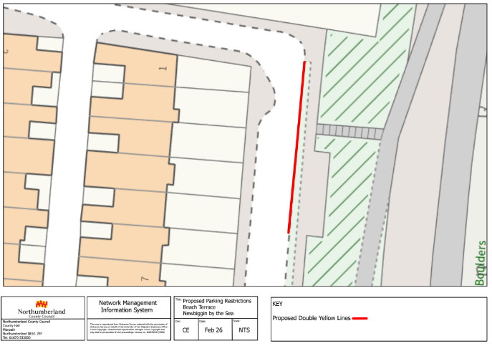

South End of Beach Terrace (Turning Area)

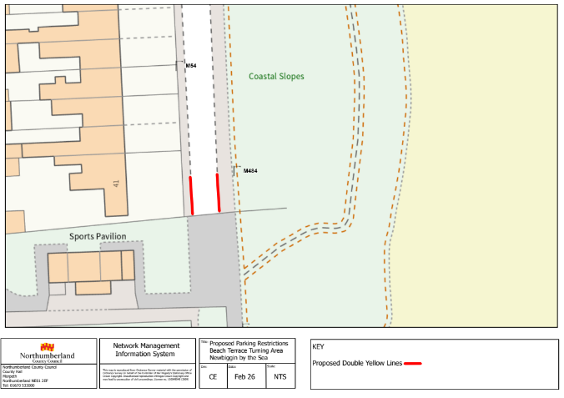

RESOLVED that: Members agreed for representatives to meet with a representative from Highways to discuss further. Recommended response to be shared response to be shared before submission.

C109/25 BEACH AND PROMENADE

C110/25 CONSIDER ADOPTION OF THE DRAFT DISPLAY SCREEN EQUIPMENT (DSE) EYE TEST POLICY
Members are asked to consider the adoption of a Draft Display Screen Equipment (DSE) Eye Test Policy following its review at the Finance and HR Committee meeting on the 21st January 2026.

Under the Health and Safety (Display Screen Equipment) Regulations 1992, employers are legally required to provide eye and eyesight tests, on request, for employees who regularly use display screen equipment as part of their role. Newbiggin Town Council meets this definition; however, there is currently no formal policy in place to address eye tests or reimbursement for eligible officers.

The Finance and HR Committee reviewed the draft policy and agreed that its adoption would:
- Ensure compliance with statutory health and safety obligations;
- Reduce potential legal risk;
- Support employee health and wellbeing;
- Provide clarity and consistency in practice; and
- Enable appropriate monitoring and review arrangements through the Town Clerk and the Finance and HR Committee.

The Finance and HR Committee resolved to recommend adoption of the policy with effect from 1st January 2026 and made several supporting recommendations regarding reimbursement, budgeting, and ongoing monitoring.

RESOLVED that: Members agreed to the recommendation of the Finance and HR Committee
- Adopt the Display Screen Equipment (DSE) Eye Test Policy, effective from 1st January 2026.
- Approve reimbursement to eligible officers for DSE eye tests undertaken from 1st January 2026 onwards.
- To pay in full towards corrective appliances or occupational in nature, and the Policy to be updated with this.
- Note that the Town Clerk will ensure compliance with the policy and that it will be reviewed by the Finance and HR Committee as appropriate.
- Note that there is no dedicated budget line in the current financial year; however, funds are available within the staff salary budget should a request arise.
- Note that there is no dedicated budget line in the agreed 2026/27 budget, and that any request during that year will require specific allocation at the time by the Finance and HR Committee.
- Approved the inclusion of an appropriate budget line in the 2027/28 budget to support future reimbursements under the policy.

C111/25 TO CONSIDER CORRESPONDENCE RECEIVED IN RELATION TO THE FIREWORKS NIGHT EVENT – NOVEMBER 2025
The Chair informed members that Newbiggin Town Council received written correspondence raising concerns in relation to an event held within the town on Fireworks Night, 8th November 2025. This was received on 10th January 2026. The event was organised by Newbiggin Traders Association. In accordance with the Council’s usual procedures, the correspondence was referred to the Newbiggin Traders Association representative for comment. The written correspondence received in January was shared with members, as well as the response from the Newbiggin Traders Association. It was noted that the representative would be happy to meet with the Town Council to discuss the incident further if required.

RESOLVED that: Members agreed to a meeting with a Newbiggin Traders Association Representative.

C112/25 TO RECEIVE AN UPDATE ON FIREWORK NIGHT 2026 – UPDATE AND FORWARD PLANNING
The Chair informed members that the multiagency meeting held at the end of January took place. This meeting was to discuss the future of the fireworks night in Newbiggin. This discussion included the following;
- Confirmation that the Bonfire element will not take place in 2026; Newbiggin Traders Association has made this decision, just as they did in 2025.
- Feedback from partners and stakeholders.
- Requirements for future event planning, including applications to Natural England and completion of SAG documentation.
- Necessary insurance.
C113/25 REPORTS FOR INFORMATION TO FULL COUNCIL
113.1 Northumberland County Councillors - No report received from Cllr Karl Green; however, Newbiggin Town Council have been informed that we might see Cllr Green in future meetings. Cllr Ben Audsley provided a report and spoke with members regarding the Beach Terrace Consultation. Updated Newbiggin Town Council on issues with Royal Mail, and this is a national issue.
113.2 Northumbria Police – No report, Town Clerk to reach out and share if anything is received.
113.3 Borderlands Place Programme – Cllr A Wootton and Town Clerk updated members on the last Borderlands Meeting. Consultants have been engaged to look at the public realm.
113.4 Northumberland Association of Local Councils – Cllr J Casey and G Woodman updated members. Members were informed that Public health wish to tackle inequality, and an update from NCC on potholes and cold weather preparation.
The meeting ended at 20:06

Chairman………………………………………………………. Date……………………………….

