
Office Use Only

Received

Dedication Application 2025-2026

Newbiggin by the Sea Town Council supports the needs and principles of allowing dedication benches, trees and planters within the Parish. The Council is mindful that these facilities are enjoyed by a wide range of people. Therefore, the Council will ensure that the issue is managed and regulated for the mutual benefit of all
Privacy: Your name, email address, postal address and telephone number will be retained as contact details relating to your chosen dedication; however, if you would prefer we did not keep this information, please state in the following box Click here to enter text.
-------------------------------------------------------------------------------------------------------------------------
APPLICANT DETAILS
NAME Click here to enter text.

E-MAIL ADDRESS Click here to enter text.
ADDRESS Click here to enter text.

TELEPHONE NUMBER Click here to enter text.
YOUR DEDICATION CHOICES COST QUANTITY
BENCH - A cast iron framed seat featuring nine hardwood treated slats.
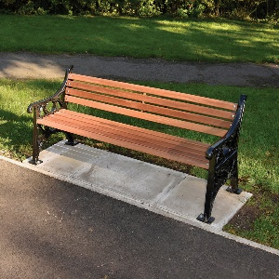 | Dedication plaques shall be affixed in the centre of the upper most lath of the bench.  Dedication benches will be installed in April and October only.  Dedication plaques will be an additional cost to the price stated to the right. | £1000 + Prices Dependant | Click here to enter text.
Preferred location

YOUR DEDICATION CHOICES COST QUANTITY
TREES – A choice of 7 trees which come supplied with a mild steel circular tree guard in black and 6” x 4” Cast bronze plaque drilled with 2 centre holes. Tree planting season runs from November to February. The tree will be planted in the dedication garden.
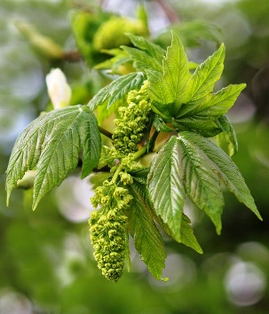 | Acer pseudoplatanus -Sycamore Maple | £379 + delivery (all prices below subject to change) | Click here to enter text.
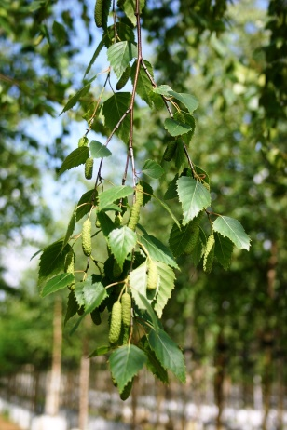 | Betula pendula - Silver Birch | £362 + delivery | Click here to enter text.
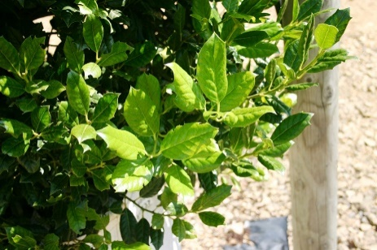 | Ilex Nellie Stevens - Holly | £396 + delivery | Click here to enter text.
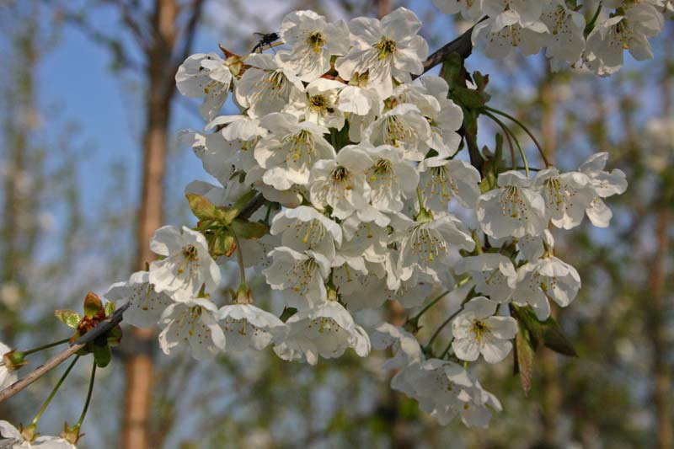 | Prunus avium - Wild Cherry | £372 + delivery | Click here to enter text.
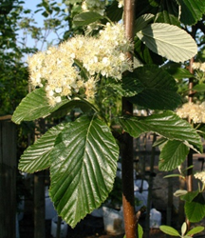 | Sorbus aria magnifica - Swedish Whitebeam | £380 + delivery | Click here to enter text.
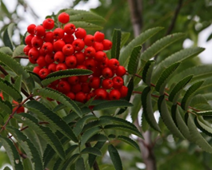 | Sorbus aucuparia Sheerwater - Rowan | £376 + delivery | Click here to enter text.
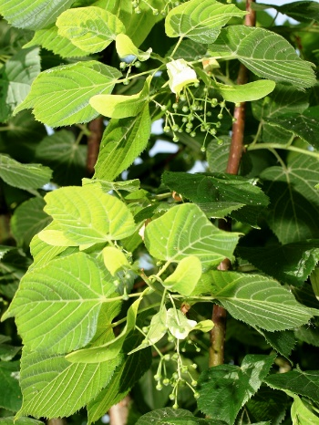 | Tilia_europaea - Small leaved lime | £377 + delivery | Click here to enter text.

DEDICATION PLAQUE (for Bench only)
Please enter below the text you would like to appear on your dedication plaque.
The inscription on the plaque is to be restricted to “In (Loving) Memory of” the name of the person and the dates of birth and death.

Click here to enter text.

Once an application has been received and location agreed, the Town Council shall arrange for the purchase and planting/installation of the preferred dedication. There is an approximate 6–10-week lead time for all orders before the months of installation. If it is too late to order given the lead time for delivery – this will then be added to the next order (April & October installation months)
The delivery charge will be dependent on the number of orders we are placing at any given time, where possible we will try to achieve best value for you by ordering in bulk and we will inform you of the total cost so you can arrange payment prior to placing the order.
POLICY ON THE DEDICATION OF SEATS, TREES AND PLANTERS WITHIN THE PARISH
Newbiggin by the Sea Town Council supports the needs and principles of allowing dedicated seats, trees and planters within the Parish. The Council is mindful that these facilities are enjoyed by a wide range of people. Therefore, the Council will ensure that the issue is managed and regulated for the mutual benefit of all.
The content of this policy will be revised as necessary to meet changing circumstances, fashion and trends. The policy will be reviewed at least every four years, and proposed amendments shall be submitted to the Council for approval.
This policy will be made available to the general public, and all applicants for dedication seats, trees and planters will be issued a copy.
OBJECTIVES OF THE POLICY
The Council is seeking to ensure it is adopting a clear, measurable and sympathetic approach to the management of assets within the town, which will take account of the sometimes-contrasting needs of a variety of users.
The policy will also ensure that all dedication benches, trees and planters have a common appearance, style and size which are appropriate for that location and will not cause offence to others.
The policy will establish responsibility for maintenance, repair and replacement. The Council, through this policy, will endeavour to always offer the highest standard of service in undertaking its management and regulatory responsibility.
Location
Every effort will be made to accommodate requests. The Council will make the final decision on the location of all memorial seats and trees after considering site capacity, health and safety and general aesthetics.
The Council will limit the number of dedication benches in particular areas so that they shall not detract from the prime purpose of the space. Therefore, the size and location of the space shall limit the number permitted. The Council reserves the right to refuse applications on this basis. The Council shall specify the type of seats to be installed to be in keeping with the intended location.
The installation of seats and planters will only take place during the months of April and October.
The planting of dedication trees shall only be carried out between November and February to ensure the most efficient growing conditions.
Dedications
Newbiggin by the Sea Town Council offers dedications within the parish, which include the following:
• Dedication tree (subject to availability)
• Dedication bench with plaque (subject to availability)
Dedication seats
Upon receipt of a donation the Town Council will supply and install a seat as close as possible to your preferred location. The seat will become an asset of the Town Council for public use and will be maintained for a period of 10 years. At the end of 10 years, the seat can be renewed, or the plaque will be removed and returned to the applicant.
The Council reserves the right to remove any seat which, in its opinion, is damaged or beyond economic repair within the 10 year period.
Dedication Trees
Upon receipt of the donation, the Town Council will supply and plant the chosen species of tree and protect it with the tree guard. Plaques shall be secured by a central pointed fixing to the tree guard.
The tree shall become the responsibility of the Town Council to maintain.
The inscription on the plaque is to be restricted to “In (Loving) Memory of” the name of the person and the dates of birth and death.
Process
Once an application has been received and a location agreed, the Town Council shall arrange for the purchase and planting/installation of the preferred dedication to take place within the relevant installation period.
The Council accepts no liability for damage to any dedication seats, trees , or planters from vandals, third parties or whilst the Council carries out routine maintenance in the park.
The Council will not grant applications for dedication seats to pets.
No additional mementoes, e.g. vases, statues, flowers, wreaths, balloons or other ornamentation, etc., shall be permitted on or around the bench. These shall be removed without reference to the original applicant.
Payment
Payment is required with every completed application form. An invoice will be sent out once the delivery fee is confirmed. Bank transfer is the preferred method of payment, although cheques will also be accepted.
Conditions
Newbiggin by the Sea Town Council reserves the right to plant trees, install seats or place memorial plaques where suitable, but will, where appropriate, accommodate requests.
Once planted/installed, the tree /seat cannot be repositioned or removed from the site.
However, should a tree or seat become unsafe, Newbiggin by the Sea Town Council reserves the right to remove it immediately in the interest of health and safety until repairs or replacement can take place.
Newbiggin by the Sea Town Council will maintain responsibility for the dedication during the 10-year period. The Council reserves the right to remove any bench or tree which in its opinion, is damaged or beyond economic repair.
Reviewed May 2025

