LOCAL GOVERNMENT ACT 1972, Sch 12 Part III

NOTICE OF ANNUAL PARISH MEETING
FOR NEWBIGGIN BY THE SEA

NOTICE IS HEREBY GIVEN THAT-

The Annual Assembly of the Parish Meeting for Newbiggin by the Sea will be held at St Bartholomew’s Church Centre on Wednesday 21st May at 18:30

Local Government electors for the Town (residents who have registered to vote) will be entitled to vote at the Meeting which will be open to the public.

The business to be transacted at the Meeting will be as follows: -

- Minutes of the last Annual Meeting – 22nd May 2024
To accept the minutes of the last Annual meeting and sign as an accurate record

- Report of the Chairman/Town Mayor
Town Council Chairman Gwen Woodman will provide a brief report on the activities of the Town Council from 2024-25

- Requested Agenda Item:
- Change to future Annual Parish Meetings

Signature
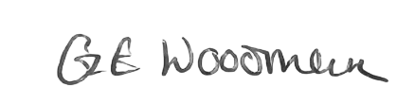

Chairman/Town Mayor
Date – 9th May 2025

