Office Use Only

Received

Dedication Application 2020-2021

Newbiggin by the Sea Town Council supports the needs and principles of allowing dedication benches, trees and planters within the Parish. The Council is mindful that these facilities are enjoyed by a wide range of people. Therefore, the Council will ensure that the issue is managed and regulated for the mutual benefit of all
Privacy: Your name, email address, postal address and telephone number will be retained as a contact details relating to your chosen dedication, however if you would prefer we did not keep this information please state in the following box Click here to enter text.
-------------------------------------------------------------------------------------------------------------------------
APPLICANT DETAILS
NAME Click here to enter text.
E-MAIL ADDRESS Click here to enter text.
ADDRESS Click here to enter text.

TELEPHONE NUMBER Click here to enter text.
YOUR DEDICATION CHOICES COST QUANTITY
BENCH - A cast iron framed seat featuring nine hardwood treated slats.
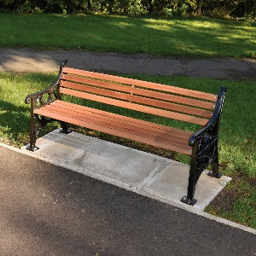 | It is the applicant’s responsibility to provide and install the dedication plaque on the bench. Dedication plaques shall be affixed in the centre of the upper most lath of the bench.  Dedication benches can be installed at any time throughout the year. | £550.00 | Click here to enter text.
Preferred location | Click here to enter text.

PLANTER – A square recycled plastic planter in blue colouring measuring 600mm Square with a 6” x 4” Cast bronze plaque drilled with 2 centre holes.
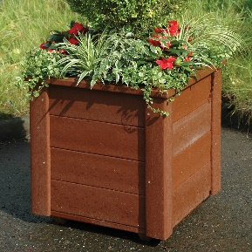 |  | £417.00 + delivery | Click here to enter text.
Preferred location | Click here to enter text.

YOUR DEDICATION CHOICES COST QUANTITY
TREES – A choice of 7 trees which come supplied with a mild steel circular tree guard in black and 6” x 4” Cast bronze plaque drilled with 2 centre holes. Tree planting season runs from November to February. The tree will be planted in the dedication garden.
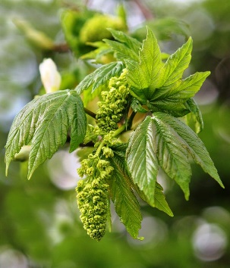 | Acer pseudoplatanus -Sycamore Maple | £379 + delivery | Click here to enter text.
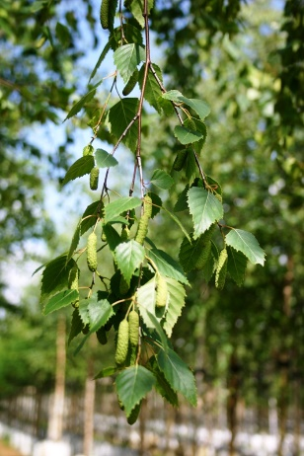 | Betula pendula - Silver Birch | £362 + delivery | Click here to enter text.
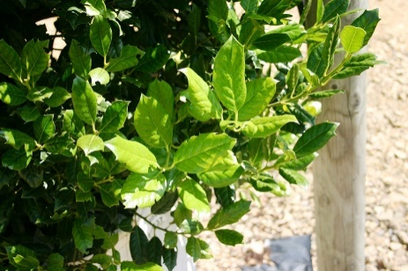 | Ilex Nellie Stevens - Holly | £396 + delivery | Click here to enter text.
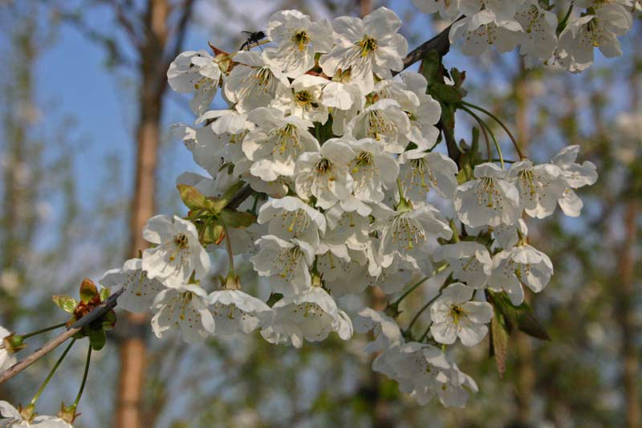 | Prunus avium - Wild Cherry | £372 + delivery | Click here to enter text.
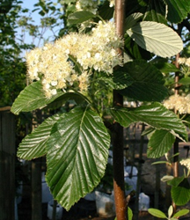 | Sorbus aria magnifica - Swedish Whitebeam | £380 + delivery | Click here to enter text.
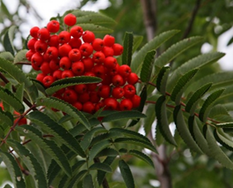 | Sorbus aucuparia Sheerwater - Rowan | £376 + delivery | Click here to enter text.
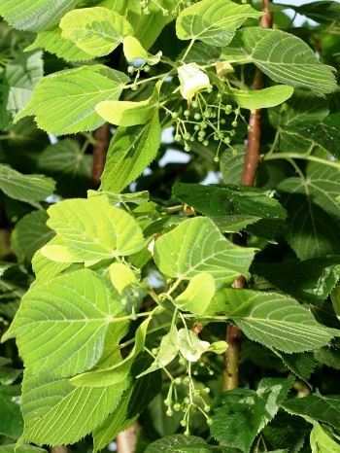 | Tilia_europaea - Small leaved lime | £377 + delivery | Click here to enter text.

DEDICATION PLAQUE (planter and trees only)
Please enter below the text you would like to appear on your dedication plaque.
The inscription on the plaque is to be restricted to “In (Loving) Memory of” the name of the person and the dates of birth and death.

Click here to enter text.

Once an application has been received and location agreed, the Town Council shall arrange for the purchase and planting/installation of the preferred dedication. There is an approximate 6-week lead time for all orders.
The delivery charge will be dependent on the number of orders we are placing at any given time, where possible we will try to achieve best value for you by ordering in bulk and we will inform you of the total cost so you can arrange payment prior to placing the order.
Further information is available under the ‘Policy on the Dedication of Trees and Benches within the Parish’ which is available on our website or upon request.
BLANK PAGE

